Appendix Marketing

I Content Calender

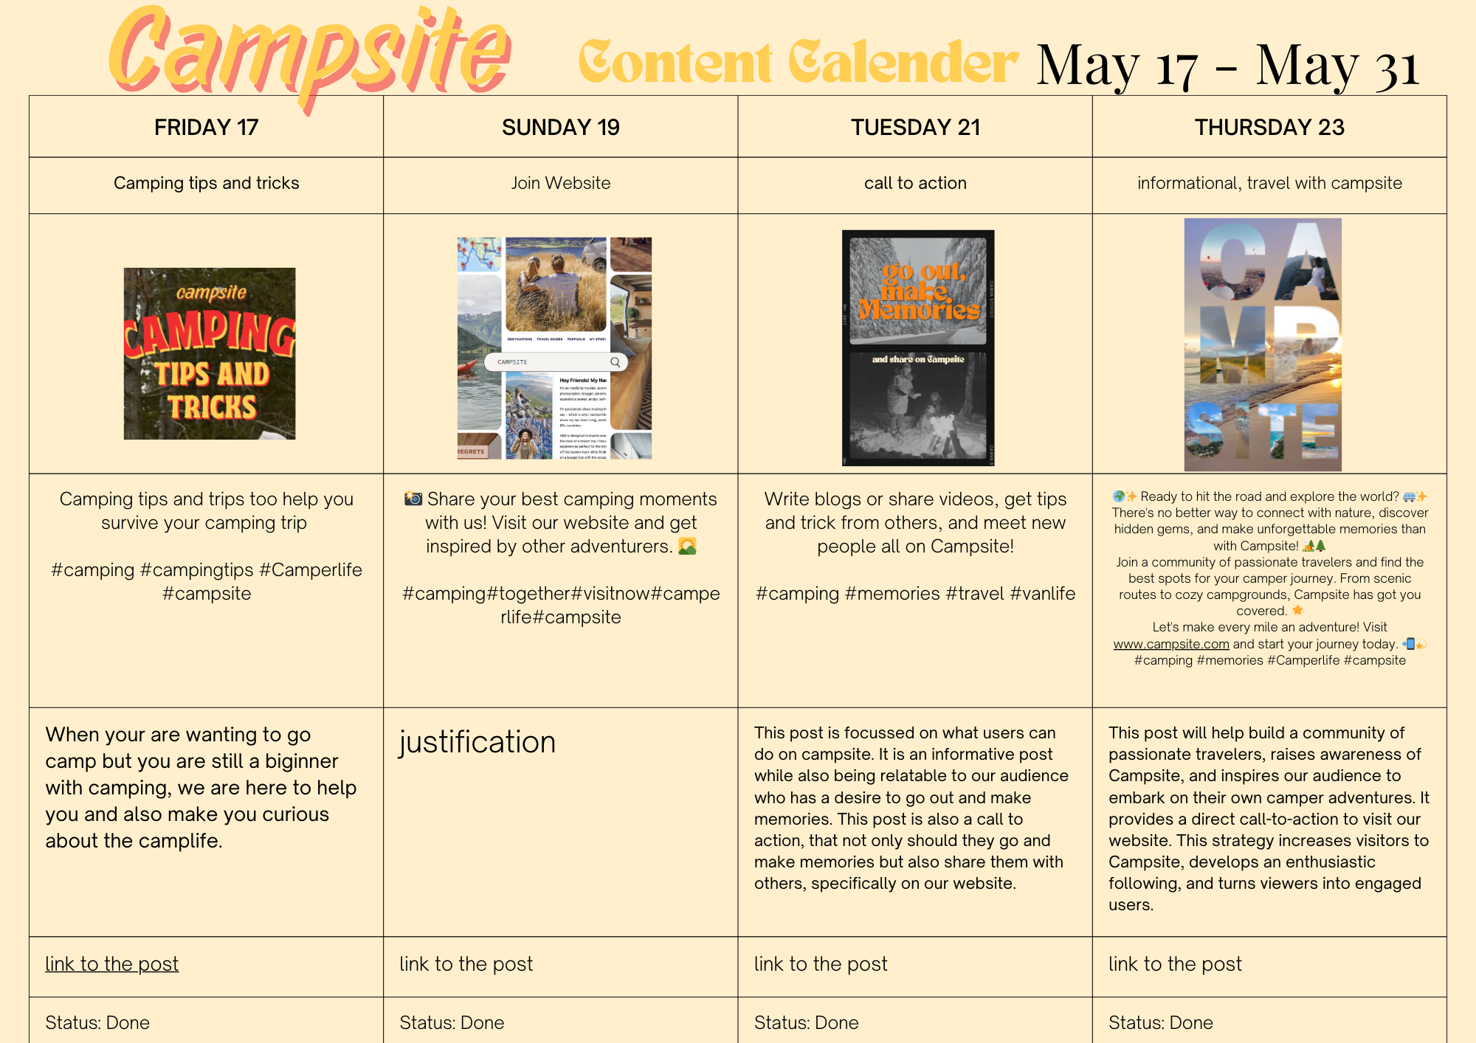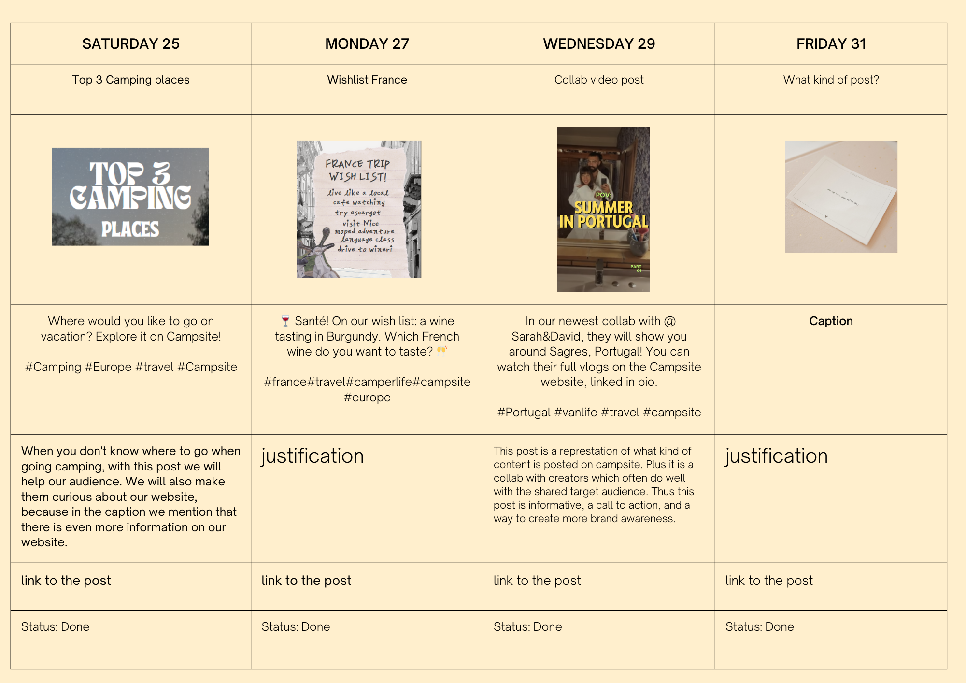

**II References**

Amzu, S. (2023, January 4). *Instagram Insights, explained: Everything you need to know about the new IG Analytics*. Flaminjoy. <https://www.flaminjoy.com/blog/instagram-insights-explained/>

Azpeitia, J. (2021). Social media marketing and its effects on TikTok users.

Król, K., & Zdonek, D. (2020). Social media use and its impact on intrinsic motivation in Generation Z: a case study from Poland. *Global Knowledge, Memory and Communication*, *70*(4/5), 442–458. https://doi.org/10.1108/gkmc-08-2020-0113

Mude, G., & Undale, S. (2023). Social media usage. *International Journal of E-business Research*, *19*(1), 1–20. https://doi.org/10.4018/ijebr.317889

Statista. (2023, January 12). *Average daily media consumption in Western Europe 2011-2021, by medium*. https://www.statista.com/statistics/1016080/daily-media-time-by-medium-in-western-europe/

*Steeds meer jongeren kopen campers en caravans*. (2023, October 2). RTL.nl. <https://www.rtl.nl/nieuws/nederland/artikel/5410761/steeds-meer-jongeren-kopen-campers-en-caravans?redirect=rtlnieuws>